DYNAMICS AX BACKUP PLAN

Contents

I. Overview 1

II. Components to backup 1

III. Database backup 1

1. Disaster Recovery backup 1

2. Local backup 2

IV. Application files backup 2

# Overview

AX system is installed on Microsoft Azure and the location is West of US.

We have setup a Disaster Recovery Plan implemented in East of US where AX can be restored and run in 30 minutes after the disaster happens, with the data of maximum 15 minutes loss.

# Components to backup

* AX Database
* AX Application files – files contain Magnussen business logic

# Database backup

## Disaster Recovery backup

* The AX Database is backup from West US location on Azure to the DR site on the East Location Azure
* The backup strategy is transaction log shipping.
* The backup frequency is 15 minutes
* Status of DR Database backup as following

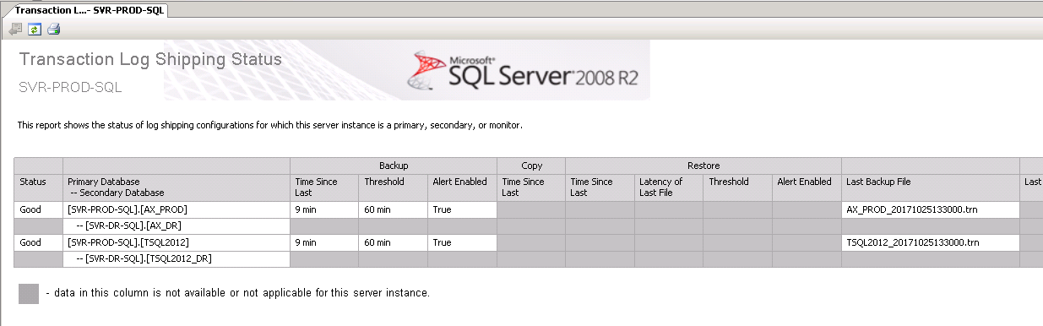

## Local backup

* Full backup of database runs 2 times a day – 7 AM and 9 PM ET time.
* Differential backup of database runs every 2 hours.

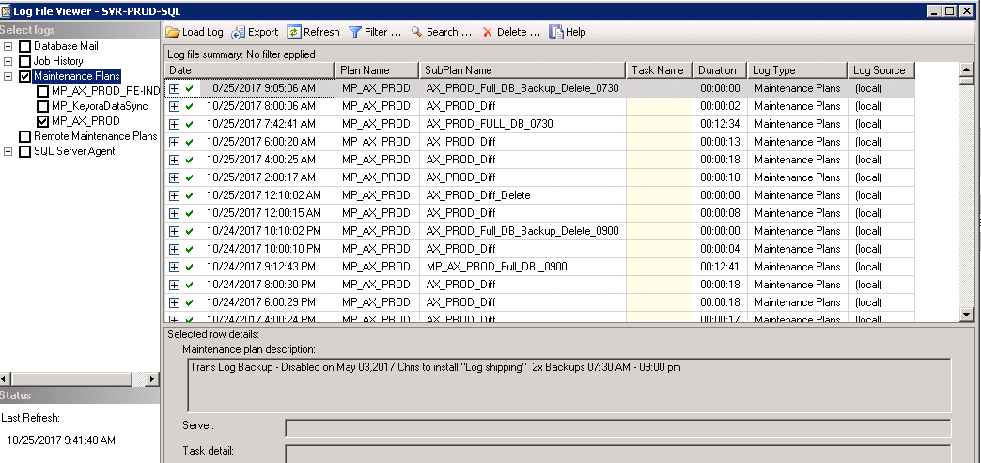

# Application files backup

We have robo-copy setup to copy the files from production application file folder to Disaster Recovery application file folder.

* Backup Strategy is overwriting the files from production to DR.
* Backup Frequency is once a day.
* Files to backup to DR site:
* **Source:**
  + Server: SVR-PROD-SQL
  + Path:      C:\Program Files\Microsoft Dynamics AX\50\Application\Appl\DynamicsAxPROD
  + Files:
    - Axusr.aod
    - Axvar.aod
    - Axbus.aod
    - axMAGen-us.ald
    - axSWXen-us.ald
* **Destination:**
  + Server: SVR-DR-SQL
  + Path:      E:\Program Files\Microsoft Dynamics AX\50\Application\Appl\DynamicsAXDR

Screenshot of the backup.

